Concurrent Resource Manager for Heterogeneous Workloads: Design and Progress Report (Review I)
Oct 15, 2026 · @Mohit Gupta

1. Problem statement
An operating system must share a few CPU cores, I/O channels and memory blocks among many tasks of different kinds, without knowing in advance how long each will run and without letting tasks deadlock each other.
CPU-bound tasks hog the processor, I/O-bound tasks need short bursts and a device, and mixed tasks sit between the two. A single fixed scheduling policy treats them all alike. Unrestricted resource grants can leave tasks each holding part of what they need while waiting for the rest, which is deadlock.
This project builds a working simulator in C on Linux that schedules such a mixed workload across concurrent threads, grants resources only when the system stays safe, and reports live statistics from a separate monitoring process.

2. Objectives and scope
The project has six objectives:
- Generate a heterogeneous workload of CPU-bound, I/O-bound and mixed tasks with random bursts and resource claims.
- Schedule it with a Multilevel Feedback Queue (MLFQ) that favours short tasks and demotes long ones.
- Allocate three resource types (CPU cores, I/O channels, memory blocks) with the Banker's algorithm so the system never enters an unsafe state.
- Run tasks on a pool of POSIX threads, with correct synchronization using mutexes and condition variables.
- Monitor the system from a separate process that reads live statistics through shared memory.
- Measure average waiting time, turnaround time and blocked unsafe requests, and compare MLFQ against a simpler policy.
In scope: a simulation on Linux (Ubuntu or WSL2) using C, GCC, POSIX threads, shared memory and semaphores. Out of scope: real device drivers, real kernel scheduling, and a graphical interface.
Limitation: because real device drivers, real kernel scheduling and a graphical interface are out of scope, the project is a user-space simulation. Tasks only sleep for their burst time instead of doing real work, I/O channels and memory blocks are counted units rather than real devices or addresses, and output is text only. Results therefore show scheduling and deadlock-avoidance behaviour, not real hardware performance.

3. Literature and background study
The design combines four classic operating-systems ideas, each with a long published history.
Multilevel Feedback Queue scheduling. MLFQ grew out of the CTSS time-sharing system at MIT in the early 1960s. It keeps several queues of different priority and moves a task down when it uses its whole time slice, so short and interactive jobs finish quickly without the OS knowing job lengths in advance. Textbooks add a periodic priority boost to prevent starvation of long jobs.
Deadlock and the Banker's algorithm. A deadlock needs four conditions together: mutual exclusion, hold-and-wait, no preemption and circular wait (Coffman et al., 1971). Dijkstra proposed the Banker's algorithm in 1965 for a single resource type, and Habermann generalised it to several types in 1969. It is deadlock avoidance: before granting a request it checks that a safe sequence still exists in which every task can finish. This is stricter than deadlock detection, which only finds a deadlock after it happens.
Producer-consumer synchronization. A shared queue protected by a mutex and a condition variable lets producer threads hand work to consumer threads, with consumers sleeping instead of busy-waiting. This is the standard pattern for thread pools.
POSIX threads and IPC. Linux offers pthread for threads, fork() for processes, shm_open plus mmap for shared memory, and named semaphores for signalling between processes. A mutex placed in shared memory needs the PTHREAD_PROCESS_SHARED attribute to work across processes.
The table shows which idea each part of the project applies.
Concept | Source idea | Where it appears in this project
MLFQ | CTSS, Silberschatz et al., OSTEP | scheduler.c, demotion in worker.c
Banker's algorithm | Dijkstra 1965, Habermann 1969 | resource_mgr.c
Producer-consumer | Standard threads pattern | task_queue.c
Shared memory and semaphores | POSIX, Kerrisk | monitor_ipc.c

4. System design and architecture
Six threads (main, generator, scheduler and three workers) and one forked monitor process cooperate through shared queues and a shared-memory block.
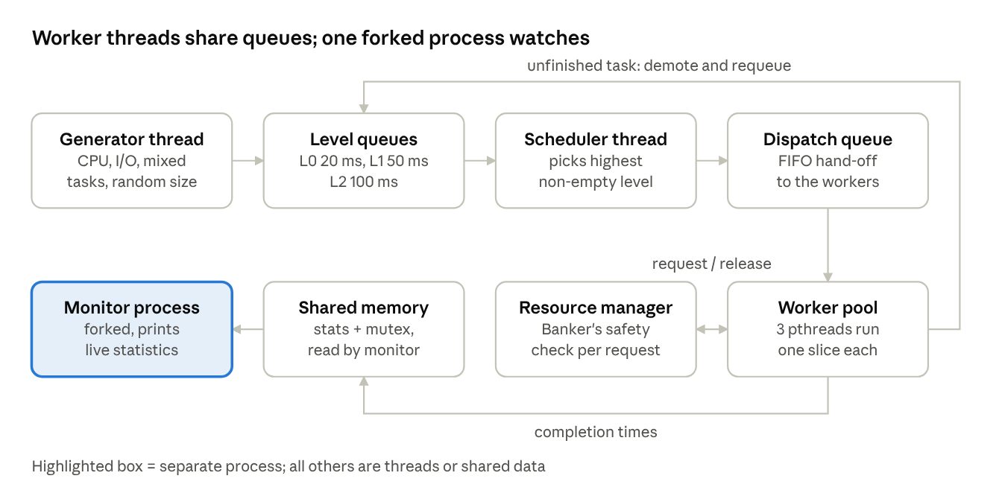
system architecture · 8 components
Tasks flow along the top row: the generator fills the level queues, the scheduler moves the best task to the dispatch queue, and a worker takes it. An unfinished task returns to a lower level. Before running, a worker asks the resource manager for resources, and it writes completion data to shared memory, which the monitor reads.
The main data structures are Task (burst, priority level, resource claims, timestamps), TaskQueue (a linked list guarded by a mutex and condition variable) and SharedStats (counters guarded by a process-shared mutex). All shared state is protected by mutexes.

5. Algorithms and flowcharts
Every task follows one loop: schedule it by level, check that resources are safe to grant, run one time slice, and either finish or requeue.
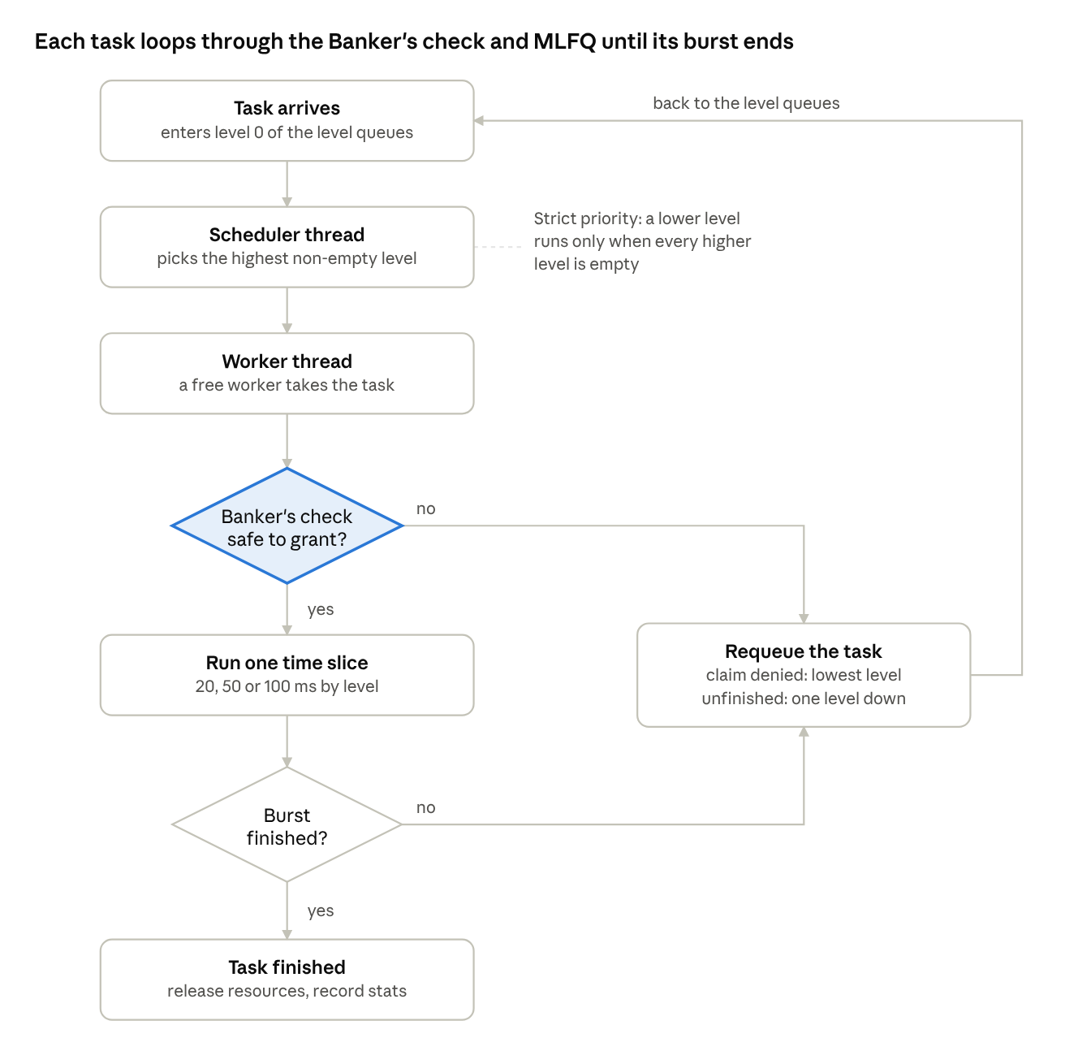
task lifecycle · 2 decisions, 1 loop
A first claim that is denied sends the task to the lowest level, so it cannot starve tasks that already hold resources. A denied mid-burst top-up keeps the task's level. A task that uses its whole slice without finishing drops one level.

MLFQ rules
- Three queues: level 0 (20 ms slice), level 1 (50 ms) and level 2 (100 ms).
- A new task enters level 0.
- The scheduler always serves the highest non-empty level; within a level, tasks run in first-come order.
- A task that uses its full slice without finishing moves down one level.
- A task whose first resource claim is denied is requeued at level 2.

Banker's safety check
Before granting a request, the resource manager grants it tentatively and tests whether every active task could still finish:
- Set work to the available units of each resource.
- Find an unfinished task whose remaining need (maximum claim minus allocation) fits within work.
- Pretend it finishes: add its allocation to work and mark it finished.
- Repeat from step 2. If every task gets marked, the state is safe and the grant stays.
- If no task fits before all are marked, the state is unsafe, so the grant is rolled back and the denial is counted.
Each task asks twice: an initial claim when it first runs, then a top-up when half its burst remains. A task can therefore hold some resources while waiting for more, which is what makes the safety check meaningful.

6. Module division among team members
Work is split three ways so each member owns one core OS concept end to end and can answer viva questions on it. Replace the placeholders with names and registration numbers.
Member | Modules owned | OS concepts | Deliverables
Mohit Gupta(24BIT0042) | workload_gen, task_queue, stats | Producer-consumer, mutexes, condition variables, performance metrics | Task model, thread-safe queue, statistics, test cases
Ganduri Suhrud Sharma(24BIT0043) | scheduler, worker, main | MLFQ scheduling, multithreading, thread lifecycle | Scheduler, worker pool, FCFS comparison mode
M Arun Srinivas (24BIT0078) | resource_mgr, monitor_ipc | Banker's algorithm, deadlock avoidance, fork(), shared memory, semaphores | Resource manager, monitor process, memory allocator

7. Implementation progress
About 70% of the planned implementation is complete, and the core simulation runs end to end. It compiles with -Wall -Wextra and zero warnings, and has been run on Ubuntu under WSL2.
Feature | Status
Thread-safe task queue (mutex + condition variable) | Done
Workload generator (CPU-bound, I/O-bound, mixed) | Done
MLFQ scheduler, 3 levels, 20/50/100 ms slices | Done
Banker's algorithm with two-phase requests | Done
Worker thread pool (3 pthreads, non-blocking requests) | Done
Monitor process with shared memory and semaphore | Done
Waiting and turnaround statistics | Done
Makefile and README | Done
FCFS comparison mode | Not started
MLFQ priority boost | Not started
Real memory allocator (first-fit, best-fit) | Not started
CPU utilization metric | Not started

Results from test runs
A run of ./crm 12 on the team's Ubuntu (WSL2) machine completed 12 of 12 tasks with an average waiting time of 349 ms, an average turnaround of 581 ms, and 1 unsafe request blocked by the Banker's algorithm.
Larger runs on the final code all completed with no hang:
Tasks | Result | Wall-clock time
12 | All completed | 1.6 s
64 | All completed | 7.4 s
120 | All completed | about 16 s
200 | All completed | about 32 s
The number of blocked unsafe requests grows with load and varies from run to run, because thread scheduling is nondeterministic. Earlier test runs showed 0 blocked requests at 8 tasks, 4 at 25 tasks and 5 at 40 tasks. Full cases are in tests/test_cases.md.

8. Challenges faced and solutions
Testing at increasing load exposed six real concurrency bugs, all now fixed.
Problem | Cause | Fix
Run stalled after the first task | Tasks were registered with the Banker's algorithm at creation, so the safety check had to prove all pending tasks could finish at once | Register a task only when a worker first picks it up
All workers frozen | A worker blocked waiting for resources and so could not run the tasks that held them (circular wait) | Non-blocking resource_mgr_try_request; a denied task is requeued and the worker moves on
Banker's algorithm never denied anything | Tasks requested their full claim at once, so hold-and-wait never occurred | Two-phase requests: an initial claim, then a top-up halfway through the burst
Near-stall at about 120 tasks | Denied tasks were requeued at the top level and, under strict priority, starved the demoted tasks holding resources | Requeue denied tasks at the lowest level
Tasks beyond 64 silently untracked | Fixed array size MAX_TASKS = 64 in the safety check | Raised to 1024; main rejects values outside 1 to 1024
Duplicated lines when output was piped | fork() copied unflushed output into the monitor process | Line-buffered stdout
A setup challenge was that the program needs real Linux features (fork(), shm_open), which Git Bash on Windows lacks. The team used Ubuntu under WSL2 instead.

9. Remaining work before Review II
Four features and the final documents remain, listed in priority order. Add target dates once the Review II date is known.
Priority | Task | Owner | Why it is needed
1 | FCFS and Round Robin comparison mode, with a results table of waiting and turnaround time | Member 2 | Review II requires performance evaluation
2 | Real memory allocator (first-fit and best-fit) with fragmentation statistics | Member 3 | Memory is currently only a count of tokens
3 | MLFQ periodic priority boost | Member 2 | Standard anti-starvation rule
4 | CPU utilization metric per worker | Member 1 | Listed in the design, not yet computed
5 | Update tests/test_cases.md with the load tests and the invalid-argument case | Member 1 | Test cases and results are a graded deliverable
6 | Final report, user manual, presentation (15 to 20 slides), GitHub push | All | Required submissions

10. References
These references were listed from memory and not opened while writing this report, so check the edition, year and page details before submitting.
- A. Silberschatz, P. B. Galvin, G. Gagne, Operating System Concepts, Wiley (CPU scheduling, deadlocks, memory management chapters).
- R. Arpaci-Dusseau and A. Arpaci-Dusseau, Operating Systems: Three Easy Pieces, chapter "Scheduling: The Multi-Level Feedback Queue" (free online).
- E. W. Dijkstra, "Een algorithme ter voorkoming van de dodelijke omarming" (EWD108), 1965 (the Banker's algorithm).
- A. N. Habermann, "Prevention of system deadlocks", Communications of the ACM, 12(7), 1969.
- E. G. Coffman, M. J. Elphick, A. Shoshani, "System Deadlocks", ACM Computing Surveys, 3(2), 1971.
- F. J. Corbató, M. Merwin-Daggett, R. C. Daley, "An Experimental Time-Sharing System", 1962 (CTSS, origin of MLFQ).
- M. Kerrisk, The Linux Programming Interface, No Starch Press, 2010 (threads, shared memory, semaphores).
- Linux manual pages: pthreads(7), shm_overview(7), sem_overview(7).

